DESIGN HEURISTICS FOR EFFECTIVE MODULARITY
Once program structure has been developed, effective modularity can be achieved by applying the design concepts introduced earlier in this chapter. The program structure can be manipulated according to the following set of heuristics:
1. Evaluate the "first iteration" of the program structure to reduce coupling and improve cohesion. Once the program structure has been developed, modules may be exploded or imploded with an eye toward improving module independence. An exploded module becomes two or more modules in the final program structure. An imploded module is the result of combining the processing implied by two or more modules. An exploded module often results when common processing exists in two or more modules and can be redefined as a separate cohesive module. When high coupling is expected, modules can sometimes be imploded to reduce passage of control, reference to global data, and interface complexity.
2. Attempt to minimize structures with high fan-out; strive for fan-in as depth increases. The structure shown inside the cloud in Figure does not make effective use of factoring. All modules are “pancaked” below a single control module. In general, a more reasonable distribution of control is shown in the upper structure. The structure takes an oval shape, indicating a number of
layers of control and highly utilitarian modules at lower levels.
3. Keep the scope of effect of a module within the scope of control of that module. The scope of effect of module e is defined as all other modules that are affected by a decision made in module e. The scope of control of module e is all modules that are subordinate and ultimately subordinate to module e. Referring to Figure, if module e makes a decision that affects module r, we have a violation of this heuristic, because module r lies outside the scope of control of module e.
4. Evaluate module interfaces to reduce complexity and redundancy and improve consistency. Module interface complexity is a prime cause of software errors. Interfaces should be designed to pass information simply and should be consistent with the function of a module. Interface inconsistency (i.e., seemingly unrelated data passed via an argument list or other technique) is an indication of low cohesion. The module in question should be reevaluated.
5. Define modules whose function is predictable, but avoid modules that are overly restrictive. A module is predictable when it can be treated as a black box; that is, the same external data will be produced regardless of internal processing details. Modules that have internal "memory" can be unpredictable unless care is taken in their use. A module that restricts processing to a single sub function exhibits high cohesion and is viewed with favor by a designer. However, a module that arbitrarily restricts the size of a local data structure, options within control flow, or modes of external interface will invariably require maintenance to remove such restrictions.
6. Strive for “controlled entry” modules by avoiding "pathological connections." This design heuristic warns against content coupling. Software is easier to understand and therefore easier to maintain when module interfaces are constrained and controlled. Pathological connection refers to branches or references into the middle of a module.
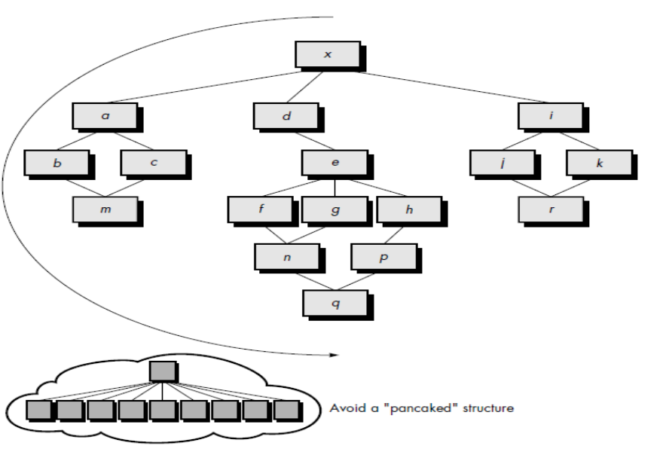

Reengineering and Reverseengineering
What is it? Consider any technology product that has served you well. You use it regularly, but it’s getting old. It breaks too often, takes longer to repair than you’d like, and no longer represents the newest technology. What to do? If the product is hardware, you’ll likely throw it away and buy a newer model. But if it’s custom-built software, that option may not be available. You’ll need to rebuild it. You’ll create a product with added functionality, better performance and reliability, and improved maintainability. That’s what we call reengineering.

Who does it? At a business level, reengineering is performed by business specialists (often consulting companies). At the software level, reengineering is performed by software engineers. Why is it important? We live in a rapidly changing world. The demands on business functions and the information technology that supports them are
changing at a pace that puts enormous competitive pressure on every commercial organization. Both the business and the software that supports (or is) the business must be reengineered to keep pace.
What are the steps? Business process reengineering (BPR) defines business goals, identifies and evaluates existing business processes, and creates revised business processes that better meet current goals. The software reengineering process mate encompasses inventory analysis, document restructuring, reverse engineering, program and data restructuring, and forward engineering. The intent of these activities is to create versions of existing programs that exhibit higher quality and better maintainability.
What is the work product? A variety of reengineering work products (e.g., analysis models, design models, test procedures) are produced. The final output is the reengineered business process and/or the reengineered software that supports it.
How do I ensure that I’ve done it right? Use the same SQA practices that are applied in every software engineering process—formal technical reviews assess the analysis and design models, specialized reviews consider business applicability and compatibility, testing is applied to uncover errors in content, functionality, and interoperability.

SOFTWARE REENGINEERING
It is an maintenance tool. Reengineering takes time; it costs significant amounts of money; and it absorbs resources that might be otherwise occupied on immediate concerns. For all of these reasons, reengineering is not accomplished in a few months or even a few years. Reengineering of information systems is an activity that will absorb information technology resources for many years. That’s why every organization needs a pragmatic strategy for software reengineering. A workable strategy is encompassed in a reengineering process model. We’ll discuss the model later in this section, but first, some basic principles. Reengineering is a rebuilding activity. We apply a software reengineering process model that defines six activities, shown in Figure. In some cases, these activities occur in a linear sequence, but this is not always the case. For example, it may be that reverse engineering (understanding the internal workings of a program) may have to occur before document restructuring can commence. The reengineering paradigm shown in the figure is a cyclical model. This means that each of the activities presented as a part of the paradigm may be revisited. For any particular cycle, the process can terminate after any one of these activities.
Inventory analysis. Every software organization should have an inventory of all applications. The inventory can be nothing more than a spreadsheet model containing information that provides a detailed description (e.g., size, age, business criticality) of every active application. By sorting this information according to business criticality, longevity, current maintainability, and other locally important criteria, candidates for reengineering appear. Resources can then be allocated to candidate applications for reengineering work. It is important to note that the inventory should be revisited on a regular cycle. The status of applications (e.g., business criticality) can change as a function of time, and as a result, priorities for reengineering will shift.
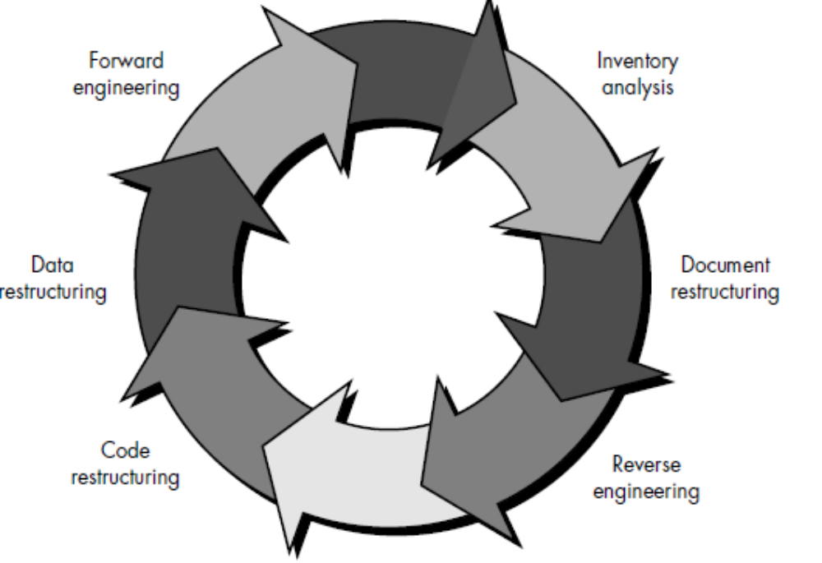

Document restructuring. Weak documentation is the trademark of many legacy
systems. But what do we do about it? What are our options?
1. Creating documentation is far too time consuming. If the system works, we’ll live
with what we have. In some cases, this is the correct approach. It is not possible
to re-create documentation for hundreds of computer programs. If a program
is relatively static, is coming to the end of its useful life, and is unlikely
to undergo significant change, let it be!
2. Documentation must be updated, but we have limited resources. We’ll use a
“document when touched” approach. It may not be necessary to fully redocument
an application. Rather, those portions of the system that are currently
undergoing change are fully documented. Over time, a collection of useful
and relevant documentation will evolve.
3. The system is business critical and must be fully re documented. Even in this
case, an intelligent approach is to pare documentation to an essential minimum.
Each of these options is viable. A software organization must choose the one that is
most appropriate for each case.
Reverse engineering. The term reverse engineering has its origins in the hardware
world. A company disassembles a competitive hardware product in an effort to understand its competitor's design and manufacturing "secrets." These secrets could be
easily understood if the competitor's design and manufacturing specifications werethe reverse engineering. In essence, successful reverse engineering derives one or more design and manufacturing specifications for a product by examining actual specimens
of the product. Reverse engineering for software is quite similar. In most cases, however, the program to be reverse engineered is not a competitor's. Rather, it is the company's own work (often done many years earlier). The "secrets" to be understood are obscure because no specification was ever developed. Therefore, reverse engineering for software is the process of analyzing a program in an effort to create a representation of the program at a higher level of abstraction than source code. Reverse engineering is a process of design recovery. Reverse engineering tools extract data, architectural, and procedural design information from an existing program.
Code restructuring. The most common type of reengineering (actually, the use of
the term reengineering is questionable in this case) is code restructuring. Some legacy
systems have a relatively solid program architecture, but individual modules were coded in a way that makes them difficult to understand, test, and maintain. In such cases, the code within the suspect modules can be restructured. To accomplish this activity, the source code is analyzed using a restructuring tool. Violations of structured programming constructs are noted and code is then restructured (this can be done automatically). The resultant restructured code is reviewed and tested to ensure that no anomalies have been introduced. Internal code documentation is updated.
Data restructuring. A program with weak data architecture will be difficult to adapt and enhance. In fact, for many applications, data architecture has more to do with the long-term viability of a program that the source code itself. Unlike code restructuring, which occurs at a relatively low level of abstraction, data structuring is a full-scale reengineering activity. In most cases, data restructuring begins with a reverse engineering activity. Current data architecture is dissected and necessary data models are defined. Data objects and attributes are identified, and existing data structures are reviewed for quality. When data structure is weak (e.g., flat files are currently implemented, when a relational approach would greatly simplify processing), the data are reengineered. Because data architecture has a strong influence on program architecture and the algorithms that populate it, changes to the data will invariably result in either architectural or code-level changes.
Forward engineering. In an ideal world, applications would be rebuilt using a automated “reengineering engine.” The old program would be fed into the engine, analyzed, restructured, and then regenerated in a form that exhibited the best aspects of software quality. In the short term, it is unlikely that such an “engine” will appear, but CASE vendors have introduced tools that provide a limited subset of these capabilities that addresses specific application domains.

REVERSE ENGINEERING
Reverse engineering conjures an image of the "magic slot." We feed an unstructured,
undocumented source listing into the slot and out the other end comes full documentation for the computer program. Unfortunately, the magic slot doesn't exist.
Reverse engineering can extract design information from source code, but the abstraction level, the completeness of the documentation, the degree to which tools and a human analyst work together, and the directionality of the process are highly variable.

The abstraction level of a reverse engineering process and the tools used to effect it refers to the sophistication of the design information that can be extracted from source code. Ideally, the abstraction level should be as high as possible. That is, the reverse engineering process should be capable of deriving procedural design representations (a low-level abstraction), program and data structure information (a somewhat higher level of abstraction), data and control flow models (a relatively high level of abstraction), and entity relationship models (a high level of abstraction). As the abstraction level increases, the software engineer is provided with information that will allow easier understanding of the program.

The completeness of a reverse engineering process refers to the level of detail that is provided at an abstraction level. In most cases, the completeness decreases as the abstraction level increases. For example, given a source code listing, it is relatively easy to develop a complete procedural design representation. Simple data flow representations may also be derived, but it is far more difficult to develop a complete set
of data flow diagrams or entity-relationship models. Completeness improves in direct proportion to the amount of analysis performed by the person doing reverse engineering. Interactivity refers to the degree to which the human is "integrated" with automated tools to create an effective reverse engineering process. In most cases, as the abstraction level increases, interactivity must increase or completeness will suffer.

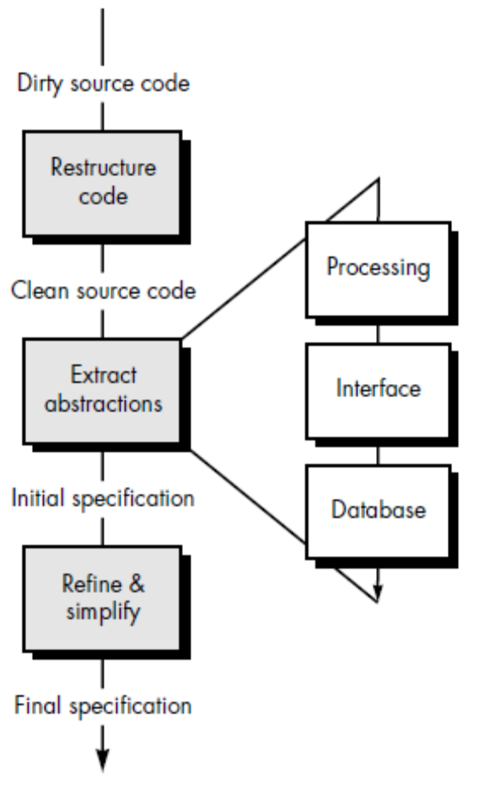

The reverse engineering process is represented in Figure. Before reverse engineering
activities can commence, unstructured (“dirty”) source code is restructured so that it contains only the structured programming constructs. This makes the source code easier to read and provides the basis for all the subsequent reverse engineering activities. The core of reverse engineering is an activity called extract abstractions. The engineer must evaluate the old program and from the (often undocumented) source code, extract a meaningful specification of the processing that is performed, the user interface that is applied, and the program data structures or database that is used.

